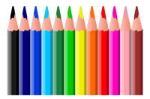

**1st Grade Supply List**

**2024-2025**

2 bottles of hand sanitizer

Water bottle/thermos with a closable top

Book bag/back pack

2 pair over the ear headphones

3 packs of pencils

3 boxes of Crayola crayons

2 glue sticks

1 pair of child’s scissors

1 pencil pouch or plastic pencil box

 2 packs of Expo dry erase markers

2 packs of erasers

 2 packs of wide-ruled notebook paper

 2 composition notebooks

4 wide ruled spiral notebooks

**Teacher’s Wish List**

2 boxes of Kleenex

2 bottles of hand soap

Sanitizing wipes